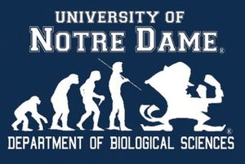
BGSO Fall 2016 events
BGSO fall picnic
Monday August 22 at 5pm
outside Galvin
BGSO beach trip
Saturday August 27 at 9:30am
Meeting at Galvin Loading Dock
BGSO monthly meeting
Monday September 5 at 5pm
Monday October 3 at 5pm
Monday November 7 at 5pm
Monday December 5 at 5pm
BGSO Concession stand
Saturday September 10
BGSO Brewery tour
Saturday October 8
BGSO Halloween Party
Friday October 28 at 4pm
Contact BGSO at: bgso.nd@gmail.com

